**Hotel Booking WordPress Plugin - Minical Hotel Booking**

Minical Hotel Booking is a fully customizable booking form with online payments, notifications, and Calendar sync. It allows you to place real-time availability calendars, property management, a directory of accommodations, and the booking engine on your website to drive direct rental property bookings.

The Minical Hotel Booking plugin is completely optimized to suit the needs of different short-term rental types. With this plugin, you can rent out unlimited vacation rentals or hotel rooms, accommodations or beds, pet boarding rooms or campsites, beds, breakfasts, guest houses. The plugin makes it a breeze to automate bookings, schedule arrivals, and get paid in advance by your guests.

This WordPress booking plugin comes with all the needed functionality to run a fully functional hospitality business website, enable payments and manage reservations in a centralized dashboard.

So if you’re ready to automate booking on your (or your client’s) website, MiniCal could be the appointment software you’re looking for. your clients can make bookings for service right on your site. No need for time-consuming phone calls or face-to-face meetings.

**The default Features of Minical Hotel Booking includes:**

* Create a beautiful listing of all your properties.
* Add unlimited accommodations, accepts unlimited bookings without you or your guest paying any extra commissions.
* Control room types and rates based on different parameters.
* Synchronize direct site reservations with popular travel channels (e.g., Channex, Airbnb, or Booking.com,) with the admin channel manager.
* Customize the property and display availability calendars.
* Allow guests to book properties and schedule arrivals online with or without instant payments via multiple integrated payment gateways.
* Add numerous booking rules, e.g., the time for arrival/departure, the min/max days to stay and more; take properties out of booking when needed.
* View business performance stats in the sales report dashboards.
* Send out automated branded emails.
* Download bookings data in CSV.

**Minical Hotel Booking Calendar**

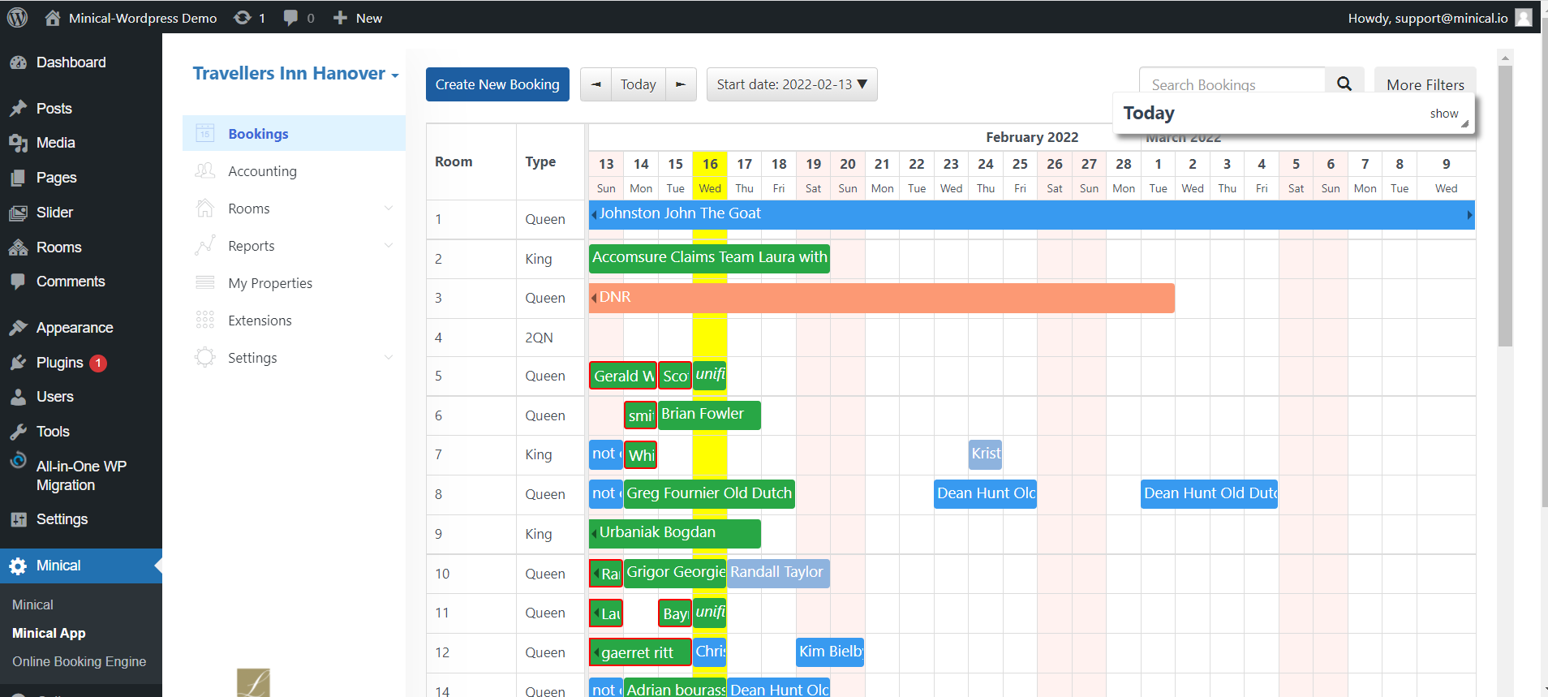

All received bookings and booking requests are stored in one place in a color-coded calendar view. You can sort all of them by status in a few clicks, view details of individual customer bookings of the past and future bookings, and manage all reservations in a centralized dashboard.

**Availability Calendars in Real-Time**

Guests can see the available and booked dates of individual properties in real-time. This time calendar plugin retrieves availability data for the common search form as well as for the individual accommodation calendars. You can also place these calendars on any page.

**Unlimited Number of Accommodations**

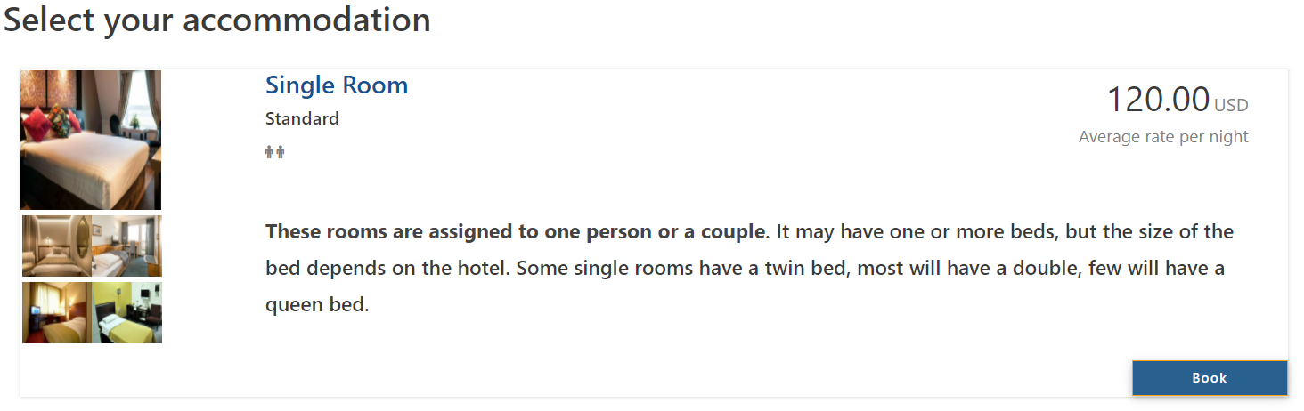

Minical allows to Add and display an unlimited number of rentals. For hotels with lots of rooms of the same type, you can generate accommodations automatically. You can add and display a property rental description, an image gallery, unlimited in-room amenities, rates, extra services and more for all individual accommodations.

**Branded Email Notifications**



Receive and send automatic notifications on each booking request with all the necessary details, including bookings details, booking status, cost, cancellation notifications, and more.

**Support to Sync Bookings Across OTAs Automatically**

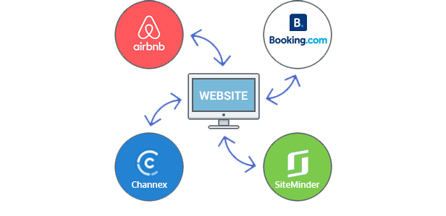

Automatic synchronization of bookings submitted through your WordPress property rental website with those from online travel agents like Airbnb, Booking.com, Channex. Avoid overbooking!

**Generate Booking Reports**

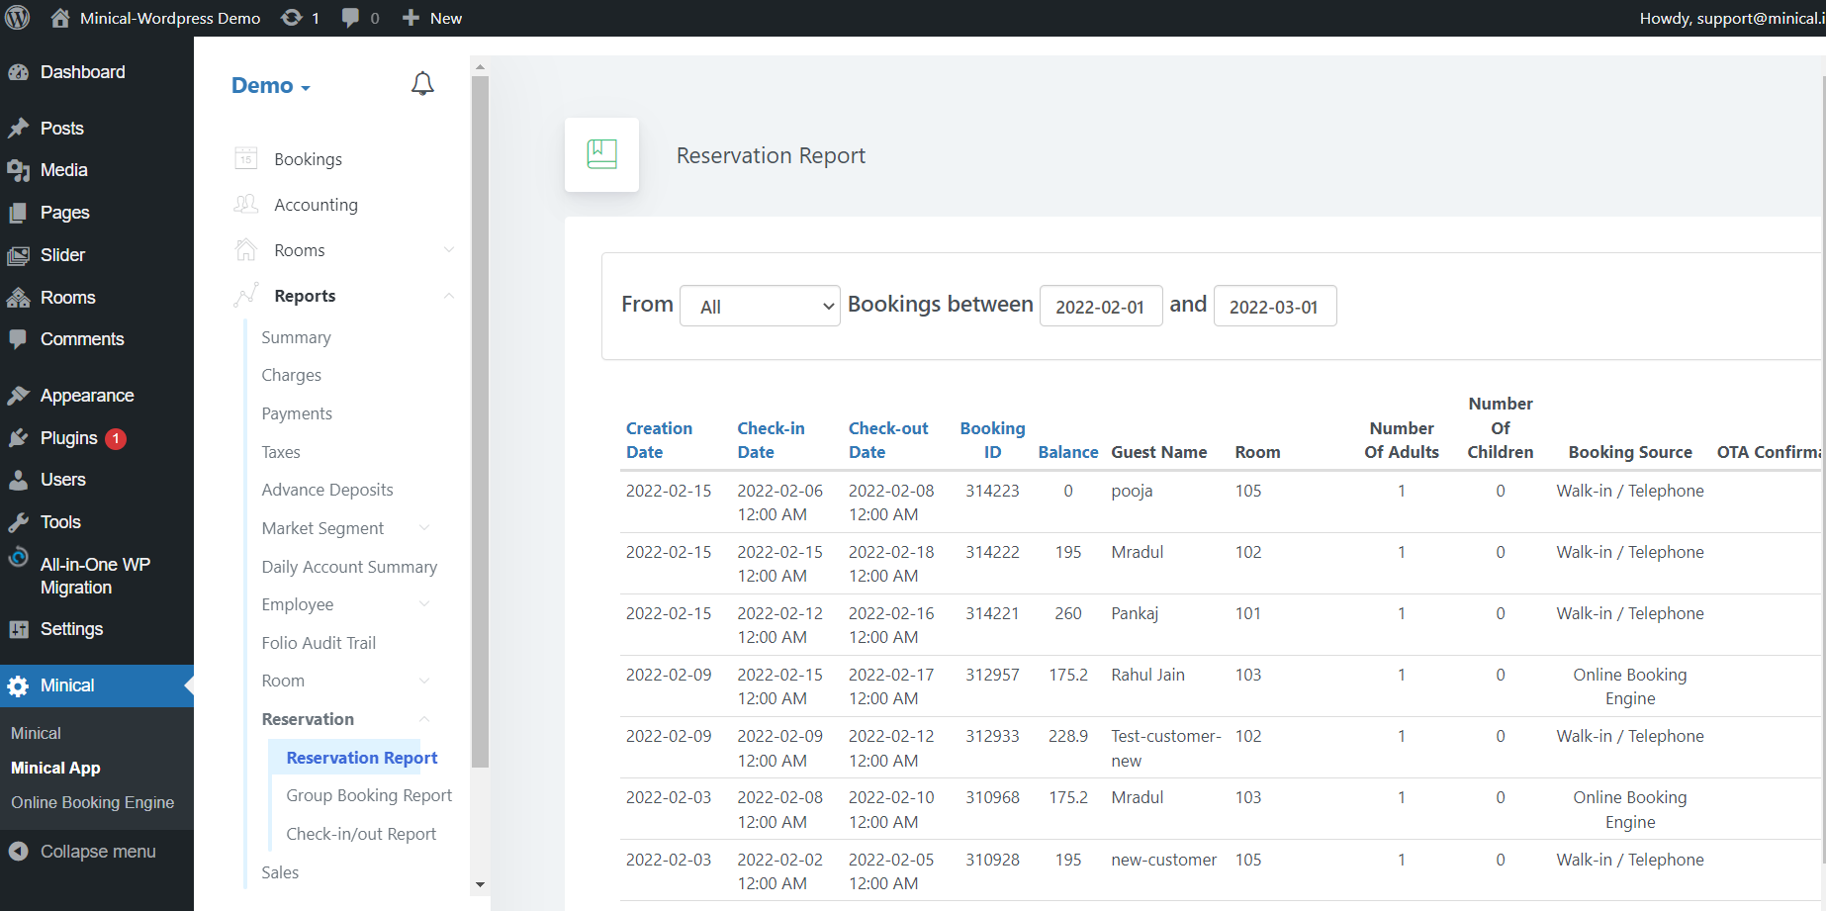

Easily generate a list of all the bookings made at your venue within a custom date range. The obtained reports are saved as CSV files that can be further opened and edited in Excel, Google Sheets and other spreadsheet software or text editor, printed out, or sent via email.

To get the most precise reports, choose among 4 exporting criteria and extract bookings filtered by check-in date, check-out date, date of reservation or total stay dates.

**Multilingual Support**



The frontend and backend of the plugin are professionally translated into 7 languages: Portuguese, English, Spanish, Korean, Vietnamese and Lithuanian (more on the way).

**Step 1: Install and sign up**

For the arrival of the Booking form page on the front, the client wants to enter the following details.

Sign up and log in with Minical.

Update rate plans and property settings.

Update room type settings.

Update online booking engine settings

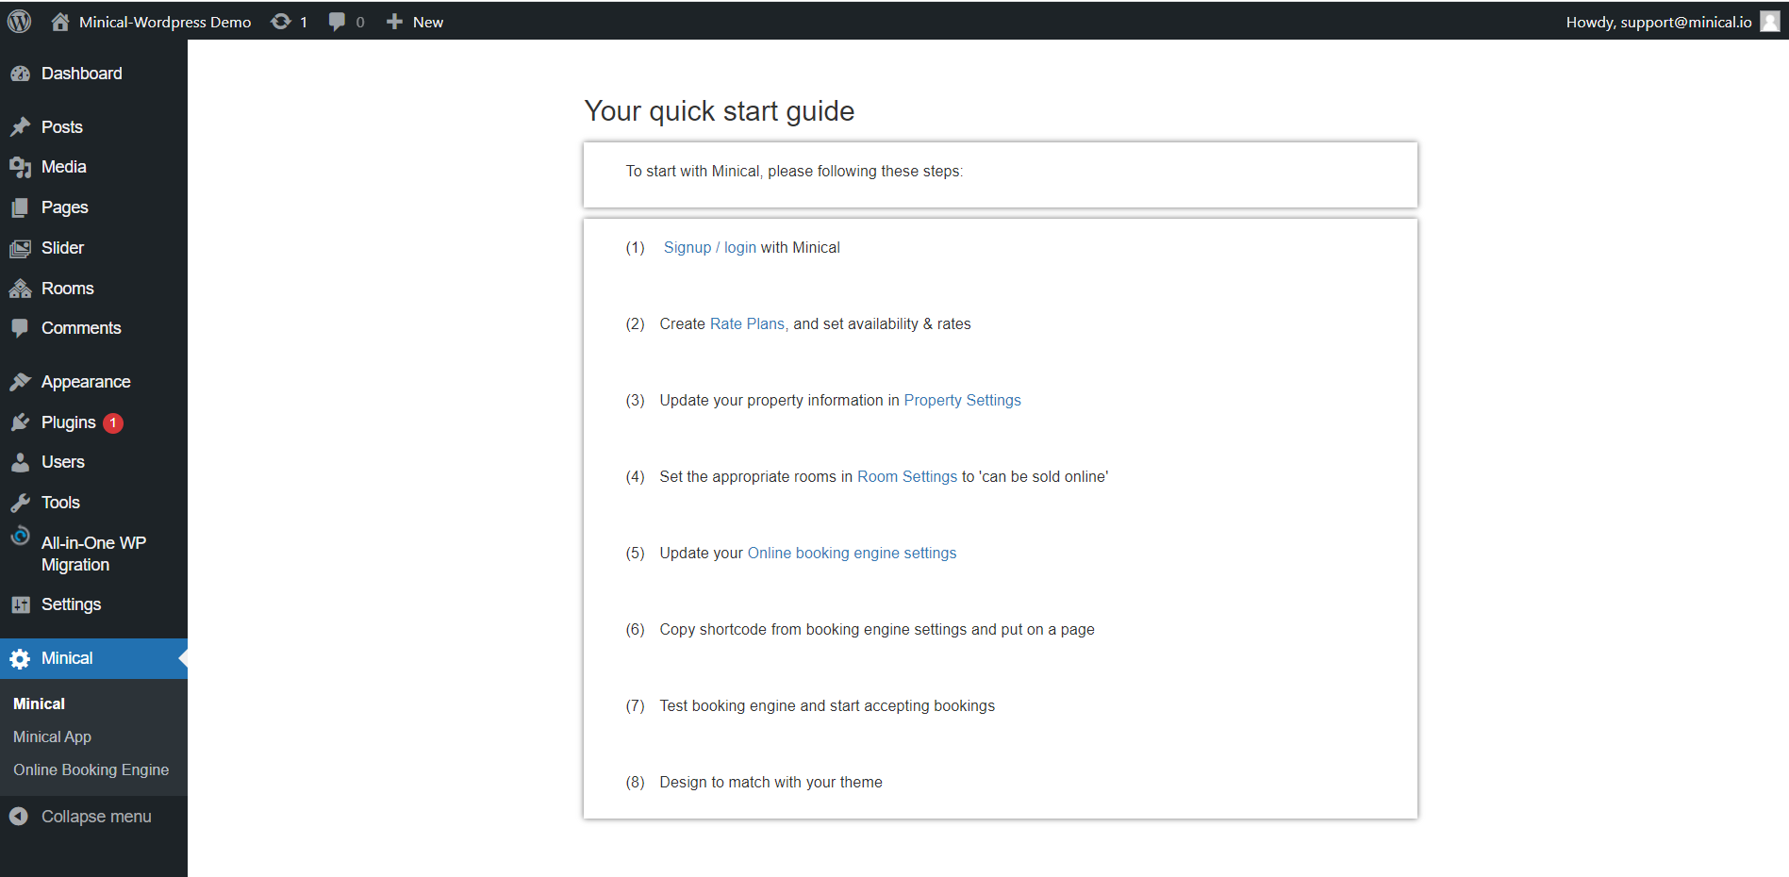

**Step 2: pick up widget code**

Based on the preferred date & time, the booking system offers a list of available time slots. The customer can pick an online booking widget code and put it on any WP page or block widget area for the Minical booking form.

You can customize the available dates that are displayed to clients. You can also change the appearance, like having each day in a separate column. Apply design look changes etc.

